Wednesday June 10 2:00 p.m. Gone Fishin’
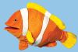
Puppet Shows: “The Fisherman and His Wife” and “The Three Little Fishes and the Big Bad Shark”, then see what you might catch in the fishing pond.

Wednesday June 17 2:00 p.m. Sounds of Music

Hear the handbells and join in the musical fun, songs, stories, instruments and activities.

Wednesday June 24 2:00 p.m. Movie Time
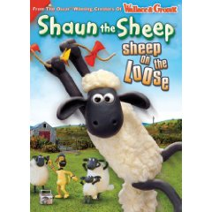
Come see the new release:
Shaun the Sheep: Sheep on the Loose.

***FRIDAY*** June 26 2:00 p.m.
DON’T MISS THE SPECIAL PERFORMANCE*
The Story Ship From Savannah GA Presents“The Circus King”
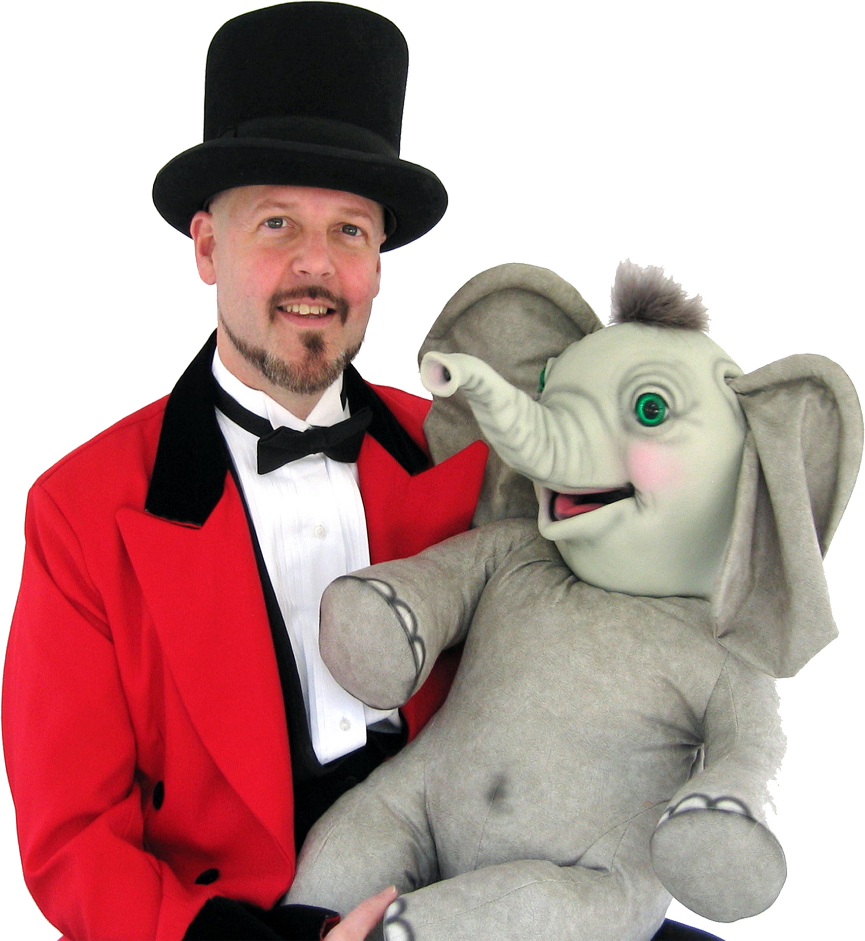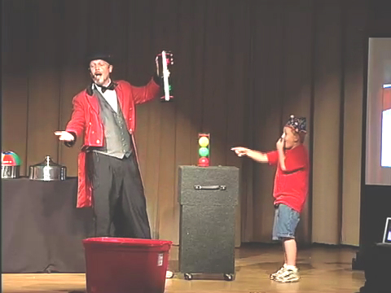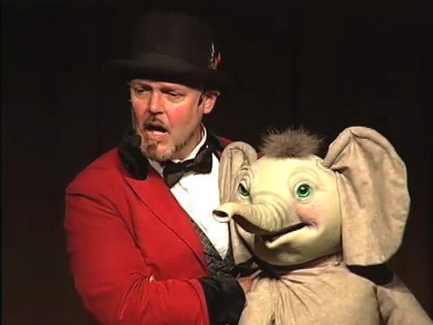
*Made possible by the Friends of the McCormick Library

Wednesday July 1 2:00 p.m. Up in the air

Watch the performing, juggling clown and try your hand at this ancient art.

Wednesday July 8 2:00 p.m. Animal Tricksters
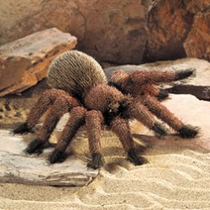
Puppet Shows: “Kiss the Brown Bunny”, “Anansi and the Moss-covered Rock” and “Who’s in Rabbit’s House.”

